OLDSMOBILE CAR SHOW
35TH Annual Pacific Northwest Zone Show
Hosted by the Puget Sound Chapter, Oldsmobile Club of America

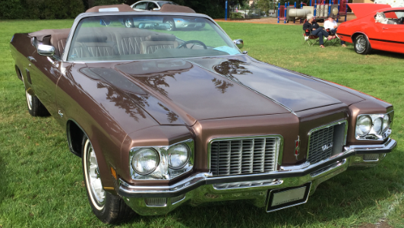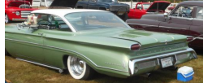
In Memory of our members: Robert Kruse Jim Rogers Ron Haave Erik Martinson 2019
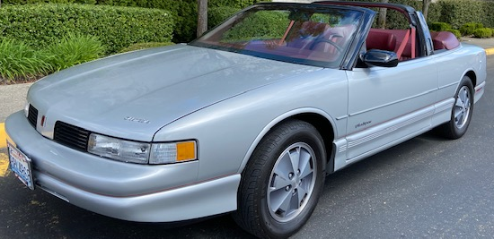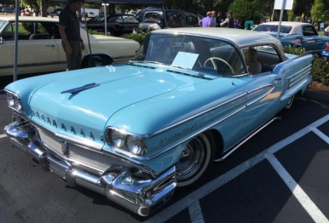
Saturday July 10, 2021
10:00am-2:00pm
Frances Anderson Center
700 Main St Edmonds WA 98029
Entry Fee $20. Please make checks payable to:
Puget Sound Chapter OCA P.O. Box 82042 Kenmore WA 98028
Name__________________________________________________
Address_________________________________________________
City ____________________________State____ Zip code_______
Email address ____________________________________________
Phone ______________________
Year ____________Body & Model ____________________________
For further information contact Ed Straw 425-485-3093 ekstraw@comcast.net
FIRE EXTINGUISHER IS REQUIRED WITH YOUR CAR

